If our Tender is accepted, we will provide a Bank Guarantee acceptable to the Purchaser in a sum equivalent to 10(%) percent of the Contract Price for the due performance of the Contract, in the form prescribe by the Purchaser.

We agree to abide by this Tender for a {{validityTerms}} fixed for the deadline tender submission and it shall remain binding upon us and may be accepted at any time before the expiration of that period.

Commission or gratuities, if any, paid or to be paid by us to agents relating to this Bid and to contract execution if we are awarded the contract, are listed below:

Name and address of Agent | Amount and currency | Purpose of Commission or Gratuity
None | None | None

Until a formal contract is prepared and executed, this bid, together with your written acceptance thereof and your notification of award shall constitute a binding contract between us.

We understand that you are not bound to accept the lowest or any bid you may receive.

We certify/confirm that, we comply with the eligibility requirement as per ITB clause 2 of the bidding Documents.



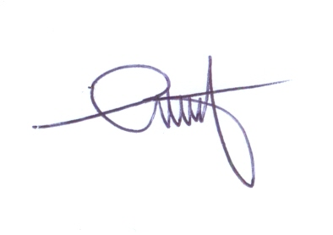

……………………………………
Signature In the capacity of Managing Director

Duly authorized to sign Tender for on behalf of BEAUTIFUL CREATIONS COMPANY LIMITED

